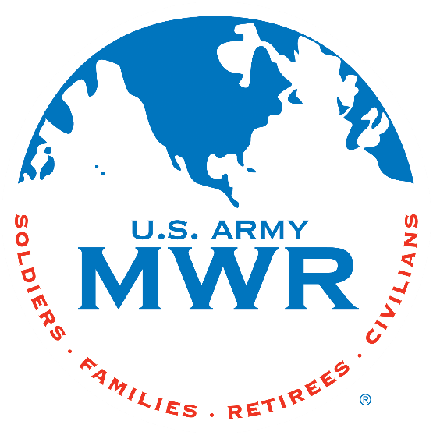**Fort Campbell Recreation Division Commitments**

**Support Military Mission**

**Enhance Well-Being**

**Build Community**

**Intramural Sports Program**

**Community Volleyball Tournament**

I, (Coaches Name) ____________________ approve my team _________________ to enter the Community Volleyball Tournament beginning on 7 Jun 2025. (Team captain Name) ___________________ will be responsible for providing all required information to the Intramural Sports Office NLT 30 May 2025. I further understand that my team is required to contact the Sports Office at (270) 798-3320 or (270) 881-7105 prior to 2pm/1400hrs if my team will not be available to play.

Coach: ______________________________

Phone Number: _______________________

Email: _______________________________

(Coach’s Signature Block)

**\* Must turn in Team Roster with this request.**

Sports Office: _____________________________

Date: ____________________________________