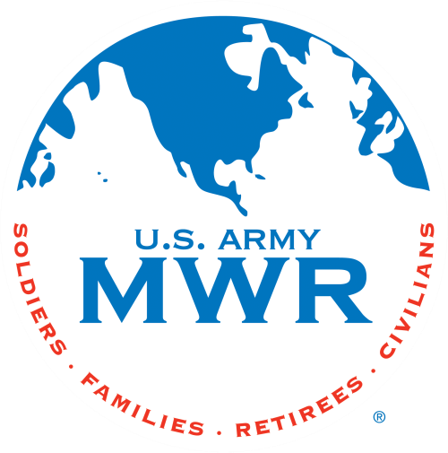
Fort Campbell Recreation Division Commitments

Support Military Mission Enhance Well-Being Build CommBattaliony

Intramural Sports Program
Battalion Level 7 vs 7 Football

I, (Commander Name) approve my company
to enter the Battalion Level 7 vs 7 Football beginning on 1 April 25. (Coach Name) _________________ will be responsible for providing all required information to the Sports Office NLT 26 Mar 25. I further understand that my Battalion is required to contact the Intramural Sports Office at 798-7586 or (270)881-7105 prior to 1400hrs if my Battalion will not be available due to mission commitments.
Coach: Phone Number: Email:

(Commander’s Signature Block)

* Must turn in Battalion Alpha Roster (minus ssn) with this request. Please HIGHLIGHT participants.

Sports Office: Date:

Process-Oriented - Team-Based - Customer-Focused - Results- Driven

