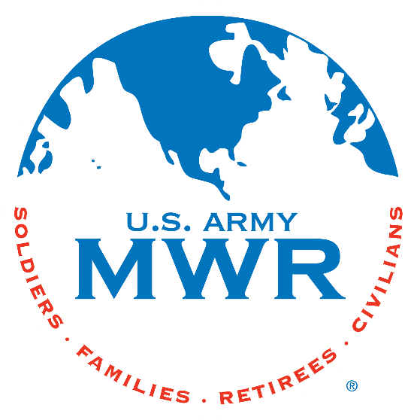
Fort Campbell Recreation Division Commitments
Support Military Mission
Enhance Well-Being
Build Community

Intramural Sports Program
Battalion Soccer Season II

I, (Commander’s Name) ____________________ approve my team _________________ to enter the Battalion Soccer Season II beginning on 8 Jul 2025. (Coach Name) ___________________ will be responsible for providing all required information to the Intramural Sports Office NLT 2 Jul 2025. I further understand that my team is required to contact the Sports Office at (270) 798-3320 or (270) 881-7105 prior to 2pm/1400hrs if my team will not be available to play.
Coach: ______________________________
Phone Number: _______________________
Email: _______________________________

(Commander’s Signature Block)

* Must turn in Team Roster with this request.

Sports Office: _____________________________
Date: ____________________________________

