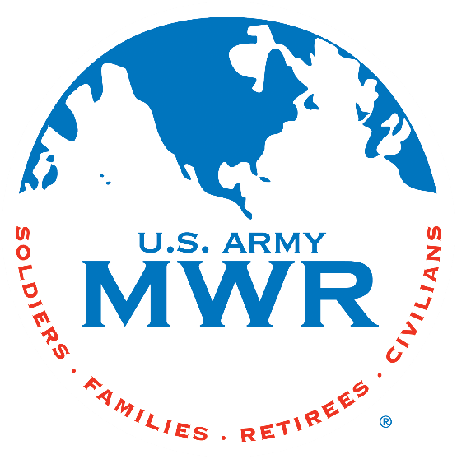**Fort Campbell Recreation Division Commitments**

**Support Military Mission**

**Enhance Well-Being**

**Build Community**

**Intramural Sports Program**

**Pickleball Tournament**

I, (Player Name) ____________________ will enter (Team Name) _________________ into the Pickleball Tournament beginning on 5 Nov 2024. We will be responsible for providing all required information to the Intramural Sports Office NLT 1 Nov 2024. I further understand that my team is required to contact the Sports Office at (270) 798-3320 or (270) 881-7105 prior to 2pm/1400hrs if my team will not be available to play.

Captain Name: ____________________________

Phone Number: _______________________

Email: _______________________________

**\* Must turn in Team Roster with this request.**

Sports Office: _____________________________

Date: ____________________________________