
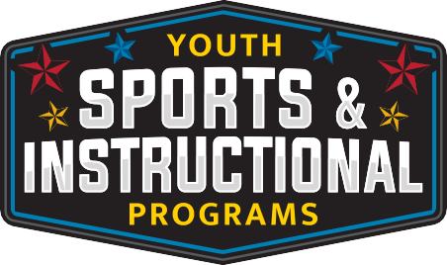
For more information, call 270-412-5811
Guitar & Ukelele
Lessons
Classes are located at 3411 Bastogne Ave, Fort Campbell, KY 42223

September 2nd -23rd

WED

Ukelele (6-18years)
16:00-16:45

Beginner
1645-1730 (6-18 years)

Advanced
1730-1815 (6-18 years)

FEES

$ 70.00 (4-week class)

GUIDANCE

Gabriel: Learn from an instructor who has 25 years’ experience in music performance and instruction at various levels, including singing, songwriting, performing and teaching guitar. These lessons are taught in a group setting.

Guitars: Guitars are available in limited quantity to use during class, students are encouraged to bring their own guitar.


Fort Campbell Youth Sports & Instructional Programs require children to be supervised in accordance with CAM Reg 608-3 “Supervision of Minor Children on Fort Campbell”. An adult is required to always remain on-site at all times during Youth Sports or Instructional Activities involving children ages 10 and under.

All participants must be registered with CYS prior to enrolling in classes. To register, go to Parent Central Services at 2702 Michigan Ave, call 270-798-0674 or register online at https://webtrac.mwr.army.mil/

