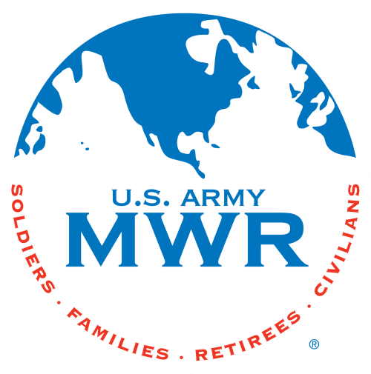
Fort Campbell Recreation Division Commitments

Support Military Mission Enhance Well-Being Build Community

Intramural Sports Program
Unit Level 5 vs 5 Indoor Soccer Tournament

I, (Commander Name) approve my company
to enter the Unit Level 5 on 5 Indoor Soccer Tournament beginning on 1 Dec 26. (Coach Name) will be responsible for providing all required information to the Sports Office NLT 27 Nov 26. I further understand that my unit is required to contact the Intramural Sports Office at 798-7504 or (270)881-7105 prior to 1400hrs if my unit will not be available due to mission commitments.
Coach: Phone Number: Email:

(Commander’s Signature Block)

* Must turn in unit Alpha Roster (minus ssn) with this request. Please HIGHLIGHT participants.

Sports Office: Date:

Process-Oriented - Team-Based - Customer-Focused - Results- Driven

