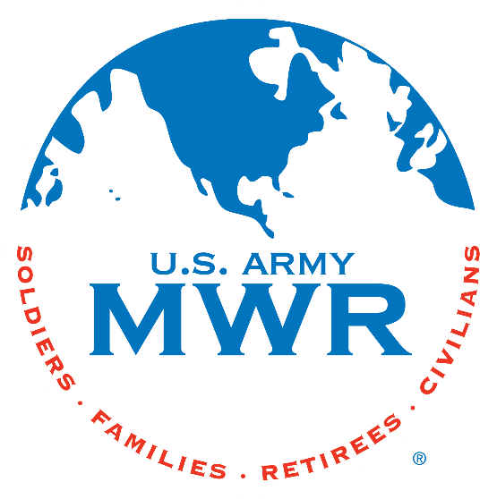
Fort Campbell Recreation Division Commitments
Support Military Mission
Enhance Well-Being
Build Community

Intramural Sports Program
March Madness Unit Basketball Tournament

I, (Commander Name) __________________________ approve my unit ____________ to enter the March Madness Unit Basketball Tournament beginning on 18 Mar 2025. (Coach Name) _______________________ will be responsible for providing all required information to the Sports Office NLT 13 Mar 2025. I further understand that my unit is required to contact the Sports Office at (270) 798-3320 or (270) 881-7105 prior to 1400hrs if my unit will not be available due to mission commitments.
Coach: ______________________________
Phone Number: _______________________
Email: _______________________________

(Commander’s Signature Block)

* Must turn in unit Alpha Roster (minus ssn) with this request. Please HIGHLIGHT participants.

Sports Office: _____________________________
Date: ____________________________________

