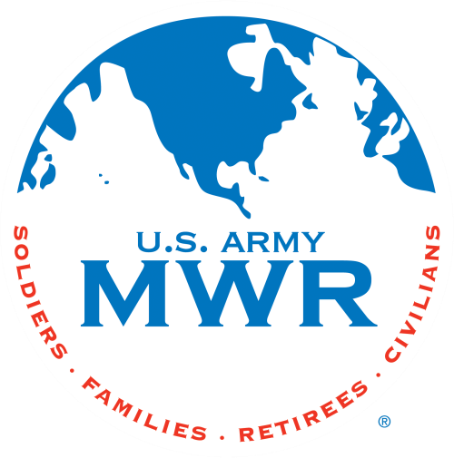**Fort Campbell Recreation Division Commitments**

# Support Military Mission Enhance Well-Being Build Community

Intramural Sports Program

**Unit Level** **Flag Football Season II**

I, (Commander Name) approve my company

to enter the Unit Level Flag Football Season Football beginning on 10 Jun 25. (Coach Name) will be responsible for providing all required information to the Sports Office NLT 4 Jun 25. I further understand that my unit is required to contact the Intramural Sports Office at 798-7586 or (270)881-7105 prior to 1400hrs if my unit will not be available due to mission commitments.

Coach: Phone Number: Email:

(Commander’s Signature Block)

# * Must turn in unit Alpha Roster (minus ssn) with this request. Please HIGHLIGHT participants.

Sports Office: Date:

**Process-Oriented - Team-Based - Customer-Focused - Results- Driven**