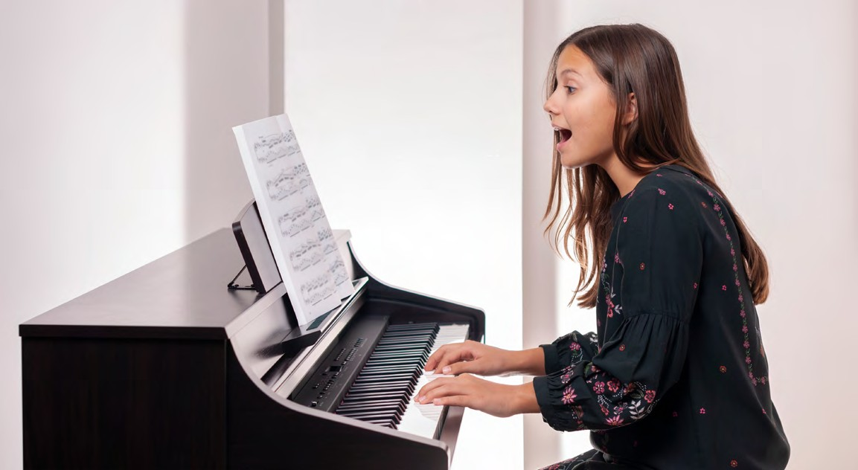
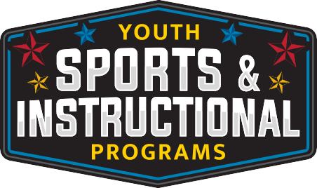
For more information, call 270-412-5811
Classes are located at 3411 Bastogne Ave, Fort Campbell, KY 42223

August 7th -28th

Friday
1700-1730
1735-1805
1810-1840
1845-1915

FEES
$85.00 (4 Private Lessons) 6-18 years

GUIDANCE

Lessons: These lessons are taught in private sessions.

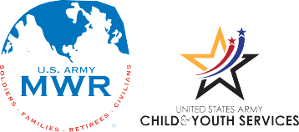
Fort Campbell Youth Sports & Instructional Programs require children to be supervised in accordance with CAM Reg 608-3 “Supervision of Minor Children on Fort Campbell”. An adult is required to always remain on-site at all times during Youth Sports or Instructional Activities involving children ages 10 and under.

All participants must be registered with CYS prior to enrolling in classes. To register, go to Parent Central Services at 2702 Michigan Ave, call 270-798-0674 or register online at https://webtrac.mwr.army.mil/

